**EXPERIMENT-13**

**AIM: Creating dashboards and storytelling, design for different displays, adding interactivity in the dashboard, distributing, publishing data visualization.**

Using the Sample-superstore, plan to create a dashboard showing the sales and profits for different

segments and Sub-Category of products across all the states.

To achieve this objective, following are the steps.

**Step 1** − Create a blank worksheet by using the add worksheet icon located at the bottom of the workbook.

Drag the dimension **Segment** to the columns shelf and the dimension **Sub-Category** to the Rows Shelf.

Drag and drop the measure **Sales** to the **Color shelf** and the measure **Profit to the Size shelf**. This

worksheet is referred as the Master worksheet. Right-click and rename this worksheet as **Sales_Profits**.

The following chart appears:

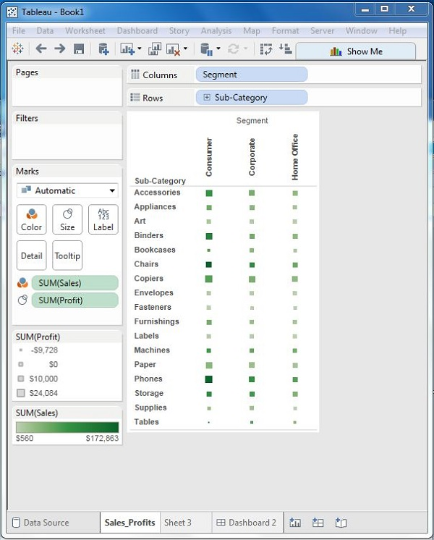

**Step 2** − Create another sheet to hold the details of the Sales across the States. For this, drag the dimension

State to the Rows shelf and the measure Sales to the Columns shelf as shown in the following screenshot.

Next, apply a filter to the State field to arrange the Sales in a descending order.

Right-click and rename this worksheet as **Sales_state**.

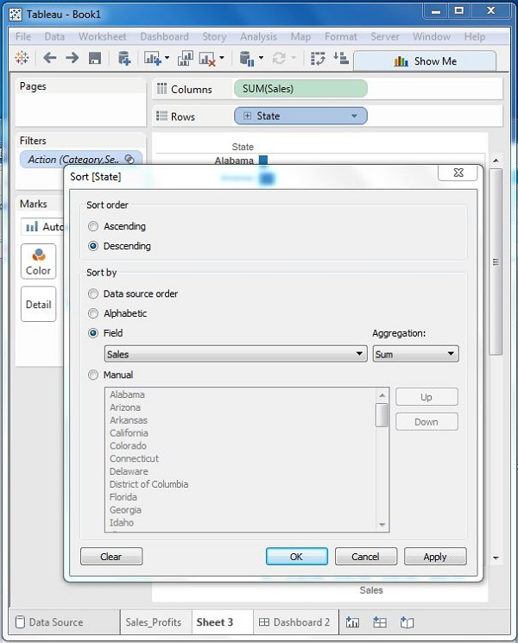

**Step 3** − Next, create a blank dashboard by clicking the Create New Dashboard link at the bottom of

the workbook.

Right-click and rename the dashboard as Profit_Dashboard.

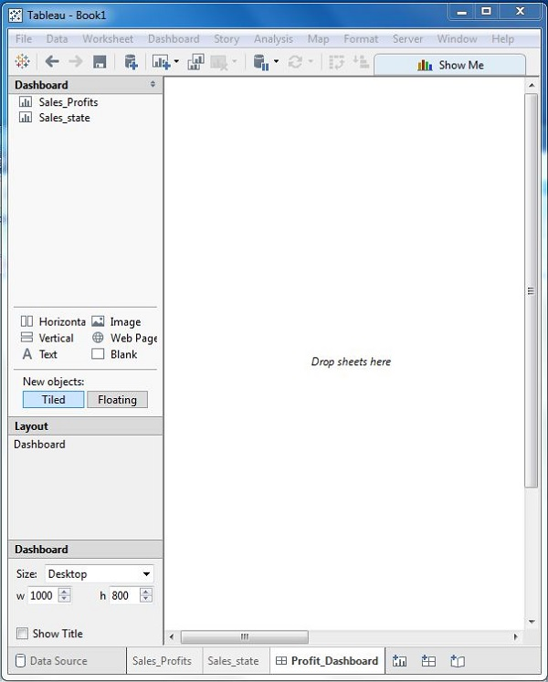

**Step 4** − Drag the two worksheets to the dashboard. Near the top border line of Sales Profit worksheet,

you can see three small icons. Click the middle one, which shows the prompt Use as Filter on hovering the mouse over it.

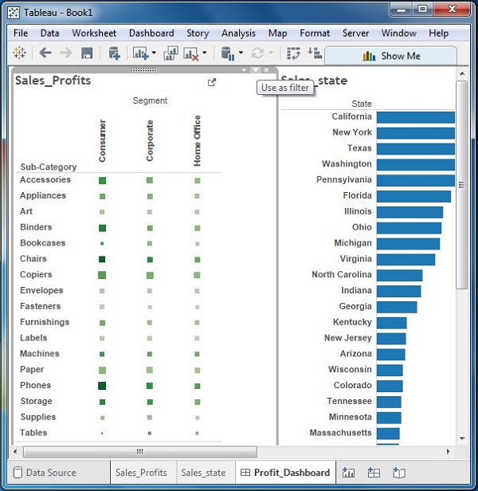

**Step 5** − Now in the dashboard, click the box representing Sub-Category named Machines and segment named Consumer.

You can notice that only the states where the sales happened for this amount of profit are filtered out in the right pane named **Sales_state**. This illustrates how the sheets are linked in a dashboard.

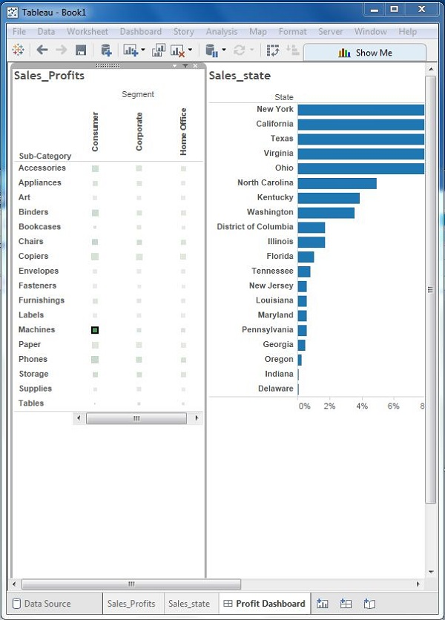

# Share your findings

# Before you continue, select an option below:

* If you or your company does not use Tableau Server, or if you want to learn about a free, alternative sharing option, jump to [Use Tableau Public](https://help.tableau.com/current/guides/get-started-tutorial/en-us/get-started-tutorial-share.htm#Use_Tableau_Public).
* If you or your company uses Tableau Server, and you are familiar with what permissions are assigned to you, jump to [Use Tableau Server](https://help.tableau.com/current/guides/get-started-tutorial/en-us/get-started-tutorial-share.htm#Use_Tableau_Server).

# When you publish to Tableau Public, as the name suggests, these views are publicly accessible.

# This means that you share your views as well as your underlying data with anyone with access to

# the internet.

1. Select **Server** > **Tableau Public** > **Save to Tableau Public**.
2. Enter your Tableau Public credentials in the dialog box.

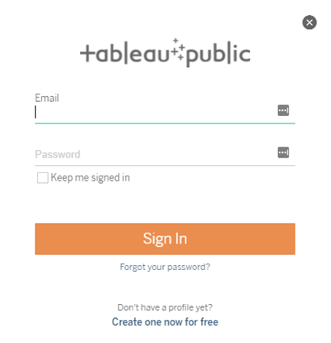

If you don't have a Tableau Public profile, click **Create one now for free** and follow the prompts.

1. If you see this dialog box, open the Data Source page. Then in the top-right corner, change the **Connection** type from **Live** to **Extract**.

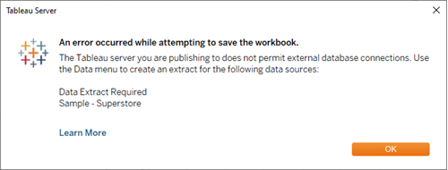

1. For the second (and last) time, select **Server** > **Tableau Public** > **Save to Tableau Public**.
2. When your browser opens, review your embedded story. It will look like this:

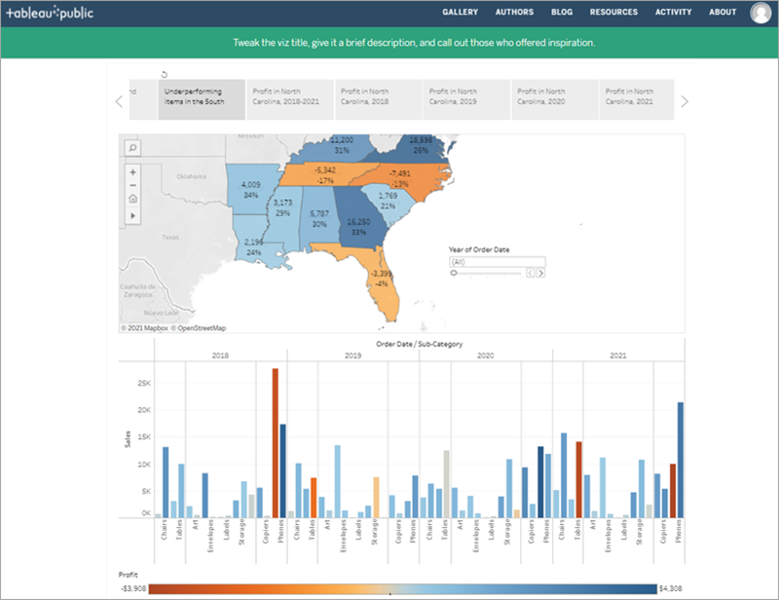

1. Click **Edit Details** to update the title of your viz, add a description, and more.
2. Click **Save**.

Your story is now live on the web.

1. To share with colleagues, click **Share** at the bottom of your viz.

